INDIAN INSTITUTE OF INFORMATION TECHONOLOGY – DHARWAD

INTERNET OF THINGS (IOT) MINI PROJECT REPORT

SUBMITTED TO – Dr. JAGADEESHA R B

DONE BY – GROUP 7

ADITI M (18BEC002)

JENNIFER YENNAM (18BEC018)

K. LAKSHMI GAYATRI (18BEC019)

BUILDING SMART GREENHOUSE USING IOT

OBJECTIVE

To build, implement and experiment smart greenhouse and it’s usage in changing and adapting according to the present climatic conditions. Typically, in tropical countries which experience either heavy rainfall or drought. The main aim is to tackle these harsh conditions for plants to grow without any obstacles.

REFERENCE PAPERS

* Green house by using IOT and cloud computing – Conference paper – May 2016 – by ~Aarthi Bakshi (Usha Mittal Institute of Technology).
* Green Internet of things (IOT) : Go Green with IOT – 2016 – by~ Prof. Monika Gadre (Asst. Professor), Mr. Chinmay Gadre (Sr. Consultant).
* IOT based Greenhouse Monitoring and Controlling – 2018 – by~ Prince Immanuel Alexander .S, Dineshkumar .J, Lavanya .G (Asst. Professor, Department of ECS).
* IOT Based Greenhouse with Climate Monitoring and Controlling System, 2018 International Conference on System Science and Engineering (ICSSE) Published in June, 2018

GREEN IOT AND APPLICATIONS

Environmental issues are acquiring more attention as the general public becomes more aware of the formidable consequences of the Environmental Degradation causes. Recent technological advances have led to an increase in the carbon footprint. The advancement in this field is paving the way for an emerging area known as Green IOT.

APPLICATIONS

* Sensors for outdoor, indoor, plants and soil.
* Equipment control.
* Remote Management.
* Analytics and Machine learning.
* Smart Farming.
* Smart Wearable.
* Smart Grids.

SMART GREENHOUSE USING IOT

Greenhouses control environmental parameters in two ways; either through manual intervention or a proportional control mechanism. However, since manual intervention has disadvantages such as production loss, energy loss, and labor cost, these methods are less effective.

A smart greenhouse through IOT embedded systems not only monitors intelligently but also controls the climate. Thereby eliminating any need for human intervention.

BLOCK DIAGRAM

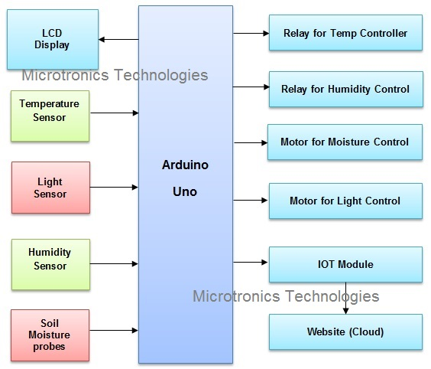

WORKING PRINCIPLE

Different sensors that measure the environmental parameters according to the plant requirement are used for controlling the environment in a smart greenhouse. Then, a cloud server creates for remotely accessing the system when it connects using IOT.

The Different sensors are used to measure the environmental parameters to the plant requirement for controlling the environment in smart greenhouse.

CIRCUIT DIAGRAM

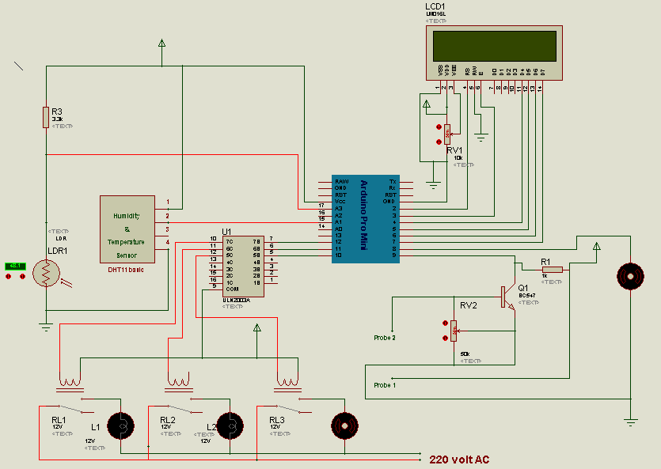

SOURCE CODE FOR SMART GREENHOUSE MONITORING

#include<LiquidCrystal.h>

#include<dht.h>

#define dht_dpin A1

#define LUX A0

LiquidCrystal lcd(2,3,4,5,6,7);

dht DHT;

#define light 10

#define fan 8

#define spray 11

#define motor 12

#define soil 9

int temperature, humidity, temp,Temp;

int check;

int test,test1,test2,test3;

float volt,lux,value;

byte degree[8] =

{

0b00011,

0b00011,

0b00000,

0b00000,

0b00000,

0b00000,

0b00000,

0b00000

};

void setup()

{

Serial.begin(9600);

lcd.begin(16,2);

pinMode(soil, INPUT);

pinMode(light, OUTPUT);

pinMode(fan, OUTPUT);

pinMode(spray, OUTPUT);

pinMode(motor, OUTPUT);

lcd.createChar(1, degree);

lcd.setCursor(0,0);

lcd.print("Green House ");

lcd.setCursor(0,1);

lcd.print(" Monitering");

delay(2000);

lcd.clear();

}

void loop()

{

/*-----Light Intensity------*/

DHT.read11(dht_dpin); //conecting dht library and pin to which the data pin of the sensor is connected

lcd.clear();

lcd.setCursor(0,0);

lcd.print(" humidity=");

lcd.print(humidity=DHT.humidity); //Reading the humidity and temperature

lcd.print(" % ");

// lcd.clear();

lcd.setCursor(0,1);

lcd.print("temperature=");

lcd.print(temperature=DHT.temperature);

lcd.write(1);

lcd.print("C ");

delay(2000);

lcd.clear();

value=analogRead(LUX); //setting the value for normal range for light intensity, temperature and humidity.

volt=(value/1023.0)*5;

lux=((2500/volt)-500)/3.3;

delay(10);

if(lux<100) // Measuring the light intensity after setting the normal range and decide whether to turn the lights ON or OFF (using if-else).

{

digitalWrite(light, HIGH);

Serial.println("AT+CMGF=1");

Serial.println("AT+CMGS="9784398922"");

Serial.println("LOW LIGHT ");

Serial.println("LIGHT TURNED ON");

Serial.print("Light Intensity: ");

Serial.print(lux);

Serial.println(" LUX");

Serial.print("Temperature: ");

Serial.print(temperature);

Serial.println(" Degree Celsius");

Serial.print("Humidity: ");

Serial.print(humidity);

Serial.println(" %");

Serial.write(26);

lcd.clear();

lcd.setCursor(0,0);

lcd.print("Low light ");

lcd.print(lux);

lcd.print(" LUX");

lcd.setCursor(0,1);

lcd.print("Lights turned ON");

check=1;

test=1;

delay(2000);

}

else

{

if(check==1)

{

Serial.println("AT+CMGF=1");

Serial.println("AT+CMGS="9784398922"");

Serial.print("LIGHT TURNED OFF");

Serial.print("Light Intensity: ");

Serial.print(lux);

Serial.println(" LUX");

Serial.print("Temperature: ");

Serial.print(temperature);

Serial.println(" degree Celsius");

Serial.print("Humidity: ");

Serial.print(humidity);

Serial.println(" %");

Serial.write(26);

check=0;

lcd.clear();

lcd.setCursor(0,0);

lcd.print("light int: ");

lcd.print(lux);

lcd.print(" LUX");

lcd.setCursor(0,1);

lcd.print("Lights turned OFF");

}

digitalWrite(light, LOW);

test=0;

delay(2000);

}

if(temperature > 40) //Measuring or detecting the Temperature using normal range whether to turn the fans ON or OFF (using if-else).

{

digitalWrite(fan, HIGH);

Serial.println("AT+CMGF=1");

Serial.println("AT+CMGS="9784398922"");

Serial.println("TEMPERATURE INCREASES FROM CRITICAL LEVEL");

Serial.println("FAN TURNED ON");

Serial.print("Light Intensity: ");

Serial.print(lux);

Serial.println(" LUX");

Serial.print("Temperature: ");

Serial.print(temperature);

Serial.println(" degree Celsius");

Serial.print("Humidity: ");

Serial.print(humidity);

Serial.println(" %");

Serial.write(26);

lcd.clear();

lcd.setCursor(0,0);

lcd.print("Temp increases ");

lcd.setCursor(0,1);

lcd.print("Fan Turned ON ");

delay(2000);

lcd.clear();

lcd.setCursor(0,0);

lcd.print("Temperature");

lcd.setCursor(0,1);

lcd.print(temperature);

lcd.write(1);

lcd.print("C");

check=2;

test2=1;

delay(2000);

}

else

{

if(check==2)

{

Serial.println("AT+CMGF=1");

Serial.println("AT+CMGS="9784398922"");

Serial.println("FAN TURNED OFF");

Serial.print("Light Intensity: ");

Serial.print(lux);

Serial.println(" LUX");

Serial.print("Temperature: ");

Serial.print(temperature);

Serial.println(" degree Celsius");

Serial.print("Humidity: ");

Serial.print(humidity);

Serial.println(" %");

Serial.write(26);

check=0;

test1=0;

}

digitalWrite(fan, LOW);

delay(1000);

}

if(humidity < 30) //Measuring or detecting the Humidity with normal range whether to turn the spray ON or OFF (using if-else).

{

digitalWrite(spray, HIGH);

digitalWrite(13, HIGH);

Serial.println("AT+CMGF=1");

Serial.println("AT+CMGS="9784398922"");

Serial.println("HUNIDITY INCREASES FROM DEFINED LEVEL ");

Serial.println("SPRAY TURNED ON");

Serial.print("Light Intensity: ");

Serial.print(lux);

Serial.println(" LUX");

Serial.print("Temperature: ");

Serial.print(temperature);

Serial.println(" degree Celsius");

Serial.print("Humidity: ");

Serial.print(humidity);

Serial.println(" %");

Serial.write(26);

lcd.clear();

lcd.setCursor(0,0);

lcd.print("Humidity increas");

lcd.setCursor(0,1);

lcd.print("Spray Turned ON ");

delay(2000);

lcd.clear();

lcd.setCursor(0,0);

lcd.print("Humidity");

lcd.setCursor(0,1);

lcd.print(humidity);

lcd.print(" %");

check=3;

test2=1;

delay(2000);

}

else

{

if(check==3)

{

Serial.println("AT+CMGF=1");

Serial.println("AT+CMGS="9784398922"");

Serial.println("SPRAY TURNED OFF");

Serial.print("Light Intensity: ");

Serial.print(lux);

Serial.println(" LUX");

Serial.print("Temperature: ");

Serial.print(temperature);

Serial.println(" degree Celsius");

Serial.print("Humidity: ");

Serial.print(humidity);

Serial.println(" %");

Serial.write(26);

check=0;

}

digitalWrite(13, LOW);

digitalWrite(spray, LOW);

test2=0;

delay(2000);

}

if(digitalRead(soil)==1) //For Soil Moisture if-else is used to decides whether watering is necessary or not

{

digitalWrite(motor, HIGH);

Serial.println("AT+CMGF=1");

Serial.println("AT+CMGS="9784398922"");

Serial.println("WATER REQUIRED ");

Serial.println("MOTOR TURNED ON ");

Serial.print("Light Intensity: ");

Serial.print(lux);

Serial.println(" LUX");

Serial.print("Temperature: ");

Serial.print(temperature);

Serial.println(" degree Celsius");

Serial.print("Humidity: ");

Serial.print(humidity);

Serial.println(" %");

Serial.write(26);

check=4;

test3=1;

lcd.clear();

lcd.setCursor(0,0);

lcd.print("Water Required ");

lcd.setCursor(0,1);

lcd.print("Motor turned ON");

delay(2000);

}

else

{

if(check==4)

{

Serial.println("AT+CMGF=1");

Serial.println("AT+CMGS="9784398922"");

Serial.println("WATER REQUIRED ");

Serial.println("MOTOR TURNED OFF ");

Serial.print("Light Intensity: ");

Serial.print(lux);

Serial.println(" LUX");

Serial.print("Temperature: ");

Serial.print(temperature);

Serial.println(" degree Celsius");

Serial.print("Humidity: ");

Serial.print(humidity);

Serial.println(" %");

Serial.write(26);

check=0;

}

digitalWrite(motor, LOW);

test3=0;

}

delay(100);

}

ADVANTAGES OF SMART GREENHOUSE

1. Automatically control environmental conditions within greenhouse allowing any type of plants to be grown all year around.
2. Eliminates risk of greenhouse not being maintained at specific environmental conditions due to human error.
3. Minimizes labor costs involved in maintaining a greenhouse.

CONCLUSION

The monitoring and controlling system of the Smart Greenhouse Automation precepts different parameters inside the greenhouse using different sensors, IOT to provide the updates. The developed system can be proved profitable as it will optimize the resources in the greenhouse. Therefore, the Smart Greenhouse using IOT has been implemented successfully.